

Sarvajanik Education Society

## Shree Ramkrishna Institute of Computer Education and Applied Sciences

Behind P.T Science College, M.T.B. College Campus, Athwalines, Surat-395 001.

**A Software Engineering Project On**

**E-Learning Website**

*as the partial fulfillment of*

**Semester -VI study**

*for the degree of*

**Bachelor of Science (Computer Science)**

*(Affiliated to Veer Narmad South Gujarat University)*

*during the academic year 2022-2023.*

## Developed By: Guided By:

Dharmi Italiya Jayesh Pushtiwala

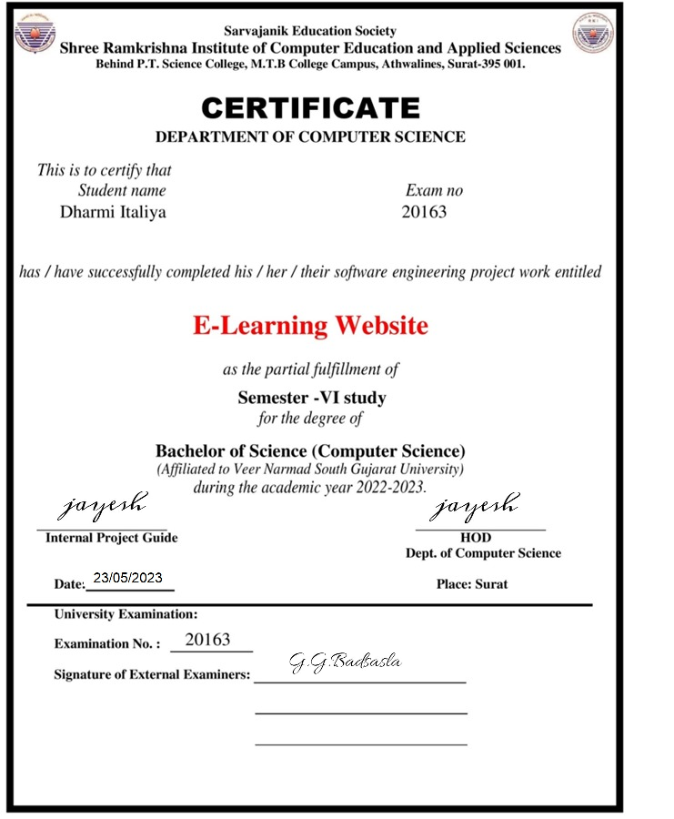

**INDEX for Project Documentation**

|  |  |  |  |
| --- | --- | --- | --- |
| **SR.NO** | **CONTENTS** | | **Page. No** |
| **1.** | **Introduction** | | 1 |
|  |  | Project Profile |  |
| **2.** | **System Introduction** | | 2 |
|  |  | System Definition, Objective and scope |  |
|  |  | Hardware & Software Requirements |  |
| **3.** | **Requirement Analysis & Modeling** | | 5 |
|  |  | Expected working of system |  |
|  | Data Flow Diagrams (DFD) |  |
|  | Process Specification |  |
|  | Data Dictionary |  |
| **4.** | **Design** | | 12 |
|  |  | ER Diagram & Database Design |  |
|  | System Architecture |  |
|  | System Flowchart |  |
|  | Form & Report Designs (Screenshots) Layouts |  |
| **5.** | **Coding** | | 28 |
|  |  | Coding Approach/style |  |
|  | Code Snippets |  |
| **6.** | **Testing** | | 35 |
|  |  | Testing Data Inputs ( Data Validations) |  |
|  | Testing Operations (Actions on each screen) |  |
| **7.** | **New Tools/ Technologies learned/used** | | 41 |
| **8.** | **System Limitations/Restrictions and Dependencies/Constraints** | | 42 |
| **9.** | **Bibliography & References** | | 43 |

1. Introduction System Profile

• Project Title =======> E-Resource System

• Organization =======> Shree Ramakrishna Institut Of

Education and Applied Sciences.

• Front -End tool =======> Visual Studio 2019(ASP.NET)

• Back -End tool =======> SQL Server Database

• Project Category =======> Source System

• Operating System =======> Windows 10 or above

• Project Duration =======> 10 Month

• Project Guided By =======> Jayesh Pushtiwala

• Developed By =======> Dharmi Italiya

**2. System Introduction**

**2.1 System Definition, Objective and scope**

**2.1.1 System Information: -**

* Our project E-Learning system is develop for all who want learn something new. they can watch them and whenever they required, they Can Retrieve them. i.e. some useful websites links (for tutorial purpose) for both of them.
* This system is most useful for the colleges, schools or any university’s students .
* At the present time, the manage video link and some important online compailer its much Complicated.
* We have two modules in this system. First is the admin and second is the uaer.
* Here admin add some important website related some courses they add this Website Link according subject.
* In this system admin have rights to add/update/delete courses,categorys,details,MCQ Questions.
* In this application student can register in system and after the login they can view the videos related selected courses. We use the SQL server database for the This application

**2.1.2 PROJECT OBJECTIVE: -**

* + Admin can add/update /delete courses,categorys,details of video,MCQ Questin.
  + User view the video of selected courses.
  + User also search the videos.
    1. **System Scope: -**
* Login function accessed by only admin.
* Admin not allow to delete any user.
* **2.2 Hardware & Software Requirements: -**

**Hardware:-**

* + Processor : Intel core i3 or above
  + Ram : 2 GB or above
  + Hard-Disk : 100 GB or above

**Software:-**

* + Backend : SQLserver Database.
  + Frontend : Visual Studio 2019.
  + Operating System : Windows 8 or above.

**3. REQUIREMENT ANALYSIS**

**3.1 Expected working of System**

**• Admin Module:**

· Admin can login with userid and password which is already store in System database. Admin can view list of users .Admin also add/delete courses , category and details about videos.

· View Users

· Manage Course

· Manage Category

· Manage Course Details

* Manage MCQ Questions

**•User Module:**

· User can register it self with only userid and password after that user can login with same userid and password. User also view the videos related to courses which they selected.

· View Course

· View Category

· View Course Details And Videos

· Search Videos With Help Of Category

**•Login Module**: Admin and User Login in this System.

**3.2 Data Flow Diagrams (DFD)**

**• CONTEXT LEVEL DFD:-**

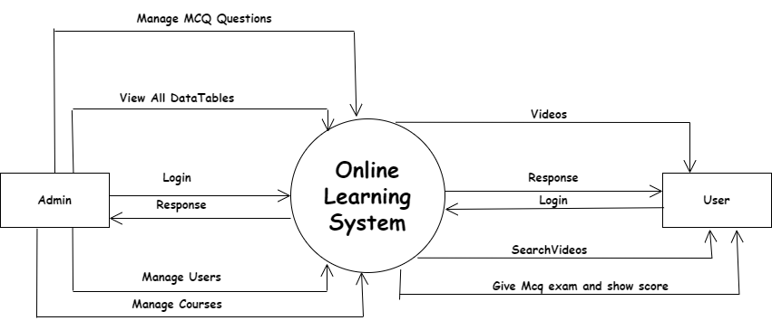

**• 1 ST LEVEL DFD FOR ADMIN:-**

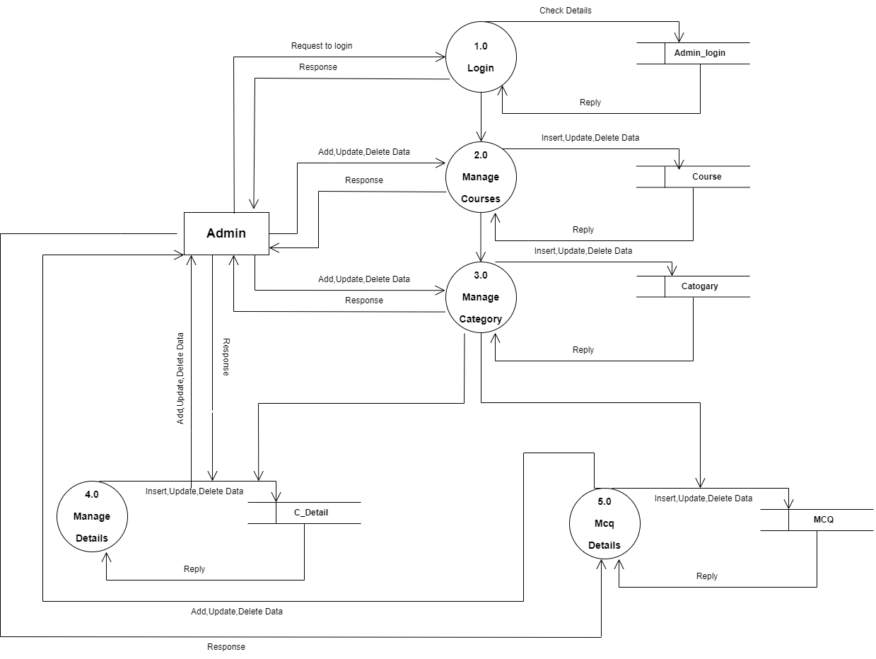

**• 1 ST LEVEL DFD FOR USER:-**

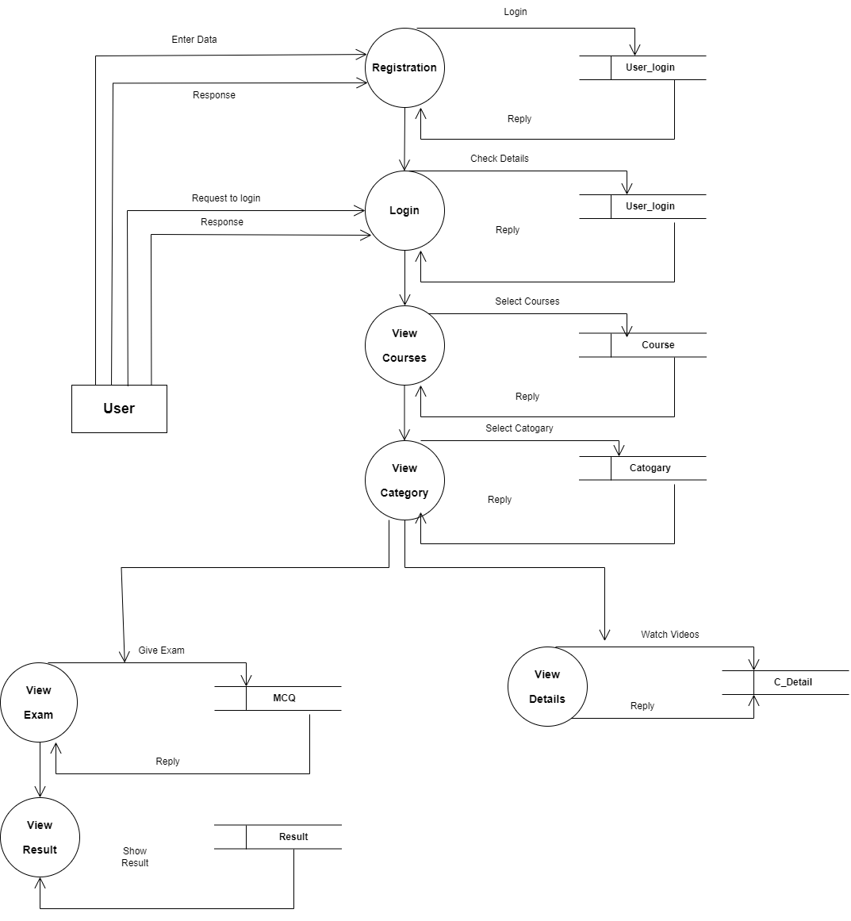

3.3 Process Specification

**• PROCESS 1.0 FOR ADMIN:**

|  |  |
| --- | --- |
| Name: | Login |
| Description: | This process is save all the information of the Admin like id And Password. |

**• PROCESS 1.0 FOR USER:**

|  |  |
| --- | --- |
| Name: | Registration |
| Description: | This process is save all the information of the User like Userid And Password. |

**• PROCESS 2.0 FOR ADMIN:**

|  |  |
| --- | --- |
| Name: | Manage Courses |
| Description: | Admin Can Insert , Update And Delete Courses |

**• PROCESS 2.0 FOR USER:**

|  |  |
| --- | --- |
| Name: | Login |
| Description: | This process is Use information of Registration Process For Login |

**• PROCESS 3.0 FOR ADMIN:**

|  |  |
| --- | --- |
| Name: | Manage Category |
| Description: | Admin Can Insert , Update And Delete Category Based On Courses |

**• PROCESS 3.0 FOR User:**

|  |  |
| --- | --- |
| Name: | View Courses |
| Description: | Users Can Select The Courses Which They Want. |

**• PROCESS 4.0 FOR ADMIN:**

|  |  |
| --- | --- |
| Name: | Manage Details |
| Description: | Admin Can Insert , Update And Delete Details Based On Courses And Category |

**• PROCESS 4.0 FOR User:**

|  |  |
| --- | --- |
| Name: | View Category |
| Description: | Users Can Select The Category Which They Want. |

**• PROCESS 5.0 FOR ADMIN:**

|  |  |
| --- | --- |
| Name: | Manage MCQ |
| Description: | Admin Can Insert , Update And Delete MCQ Based On Courses And Category |

**• PROCESS 5.0 FOR User:**

|  |  |
| --- | --- |
| Name: | View Details |
| Description: | User Can Watch The Videos Related To The Selected Courses And Category |

**• PROCESS 6.0 FOR User:**

|  |  |
| --- | --- |
| Name: | View Mcq For Exam |
| Description: | User Can give exam of Related To The Selected Courses And Category |

**• PROCESS 7.0 FOR User:**

|  |  |
| --- | --- |
| Name: | View Result of Given Exam |
| Description: | User can view score |

**3.4 Data Dictionary:**

**• Admin Table:**

|  |  |
| --- | --- |
| Name: | Admin Details |
| Alias: | Admin_login |
| Where used/How used: | Data use for particular login For Admin |
| Content Description: | Email_id+Password |

• User Table:

|  |  |
| --- | --- |
| Name: | User Details |
| Alias: | User_login |
| Where used/How used: | Data use for particular login For Uaser |
| Content Description: | Email_id+Password |

**• Course Table:**

|  |  |
| --- | --- |
| Name: | Select Course |
| Alias: | COURSE |
| Where used/How used: | Select Course use for selection of Course |
| Content Description: | C_ID+C_NAME |

**• Category Table:**

|  |  |
| --- | --- |
| Name: | Select Category |
| Alias: | Category |
| Where used/How used: | Select Category use for selection of Category |
| Content Description: | CAT_ID+CAT_NAME+C_ID |

**• Details Table:**

|  |  |
| --- | --- |
| Name: | Watch Videos |
| Alias: | Details |
| Where used/How used: | Watch Videos use for watch videos with selected course and category |
| Content Description: | D_ID+C_ID+CAT_ID+C_LINK+C_PHOTO  +COURSE_DETAILS+search_value |

**• MCQ Table:**

|  |  |
| --- | --- |
| Name: | Show Mcq |
| Alias: | MCQ |
| Where used/How used: | Can give exam of Related To The Selected Courses And Category |
| Content Description: | Id + C_ID +CAT_ID+ QUESTION +O1 +O2 +O3+O4+ANSWER |

**4. Design**

**4.1 ER Diagram :**

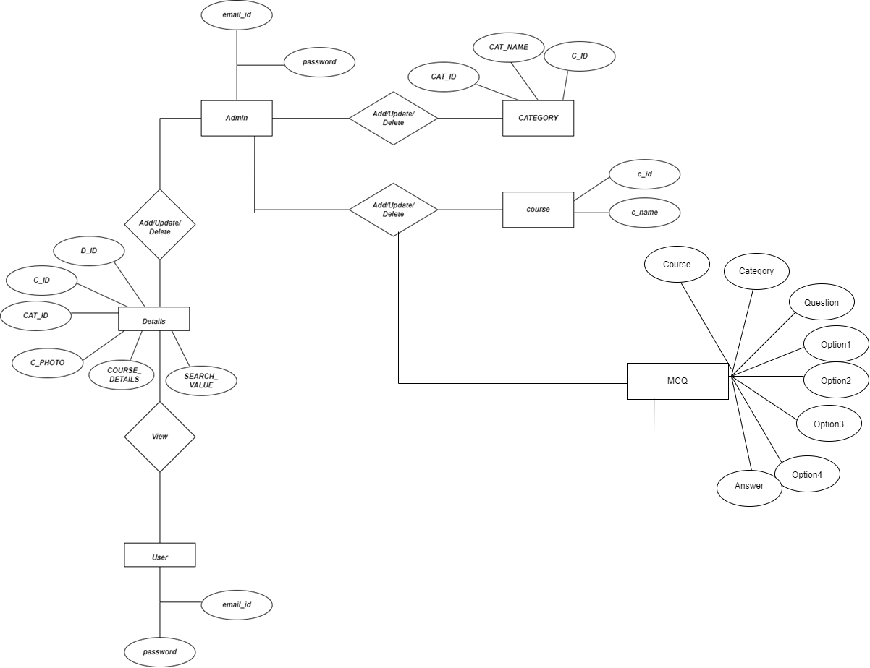

**4.1 Database Design**

**➢ Table Name: Admin_login**

|  |  |  |  |  |
| --- | --- | --- | --- | --- |
| Field Name | Data Type | Constraints | Field Size | Description |
| Email_id | NVARCHAR | Primary Key | 50 | Contains ID of Admin |
| Password | NVARCHAR |  | 50 | Contains Password of admin |

**➢ Table Name: Course**

|  |  |  |  |  |
| --- | --- | --- | --- | --- |
| Field Name | Data Type | Constraints | Field Size | Description |
| C_ID | Int(Auto Number) | Primary Key |  | Contains ID of Course |
| C_NAME | nvarchar |  | 50 | Contains name of Course |

**➢ Table Name: Category**

|  |  |  |  |  |
| --- | --- | --- | --- | --- |
| Field Name | Data Type | Constraints | Field Size | Description |
| CAT_ID | Int(Auto Number) | Primary Key |  | Contains ID of Category |
| CAT_NAME | nvarchar |  | 50 | Contains name of Category |
| C_ID | Int | Foreign Key |  | Contains ID of resources data Course |

**➢ Table Name: User_login**

|  |  |  |  |  |
| --- | --- | --- | --- | --- |
| Field Name | Data Type | Constraints | Field Size | Description |
| Email_id | NVARCHAR | Primary Key | 50 | Contains ID of User |
| Password | NVARCHAR |  | 50 | Contains Password of User |

**➢ Table Name: C_DETAILS**

|  |  |  |  |  |
| --- | --- | --- | --- | --- |
| Field Name | Data Type | Constraints | Field Size | Description |
| D_ID | int | Primary Key |  | Contains ID of DETAILS |
| C_ID | int | Foreign Key |  | Contains ID of resources data Course |
| CAT_ID | int | Foreign Key |  | Contains ID of resources data Category |
| C_LINK | nvarchar |  | 50 | Contains link of DETAILS |
| C_PHOTO | nvarchar |  | 50 | Contains photo of DETAILS |
| COUSE_DETAILS | nvarchar |  | 50 | Contains description of DETAILS |

**➢ Table Name: MCQ**

|  |  |  |  |  |
| --- | --- | --- | --- | --- |
| Field Name | Data Type | Constraints | Field Size | Description |
| Id | int | Primary Key |  | Contains ID of MCQ |
| Course | int | Foreign Key |  | Contains ID of resources data Course |
| Category | int | Foreign Key |  | Contains ID of resources data Category |
| Question | int | Foreign Key |  | Contains Question of  MCQ |
| Option1 | nvarchar |  | 50 | Contains 1st Option of  MCQ |
| Option2 | nvarchar |  | 50 | Contains 2nd Option of  MCQ |
| Option3 | nvarchar |  | 50 | Contains 3rd Option of  MCQ |
| Option4 | Nvarchar |  | 50 | Contains 4th Option of  MCQ |
| Answer | nvarchar |  | 50 | Contains First Answer of  MCQ |

**4.3 System Flowchart**

**Admin Side:**

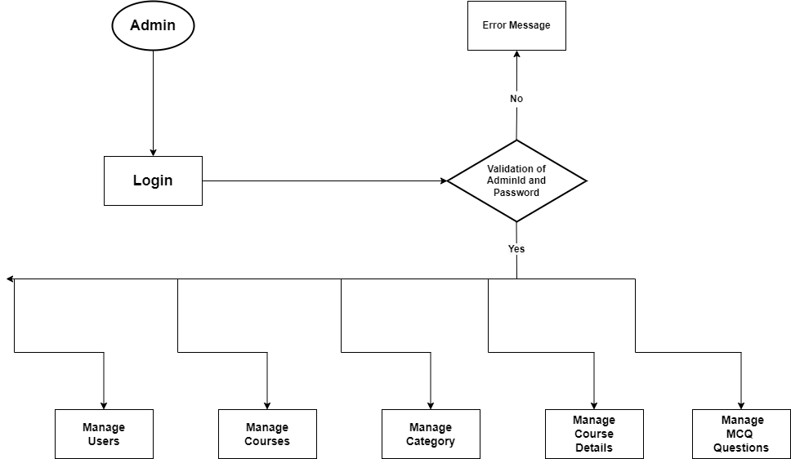

**User Side:**

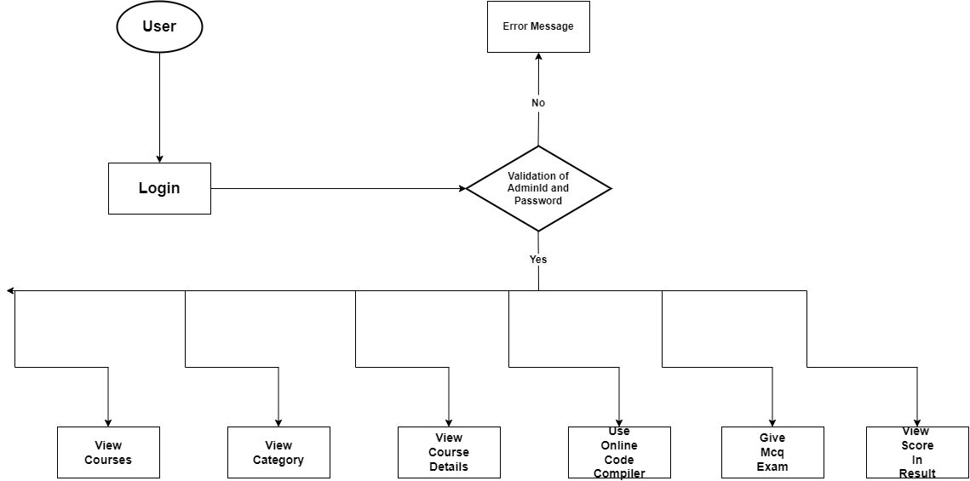

**4.4 Form & Report Designs (Screenshots) Layouts**

**• Login Page For User And Admin**

* Login page used by admin and user to login in e-learning system.
* Login done with email and password of admin And user.

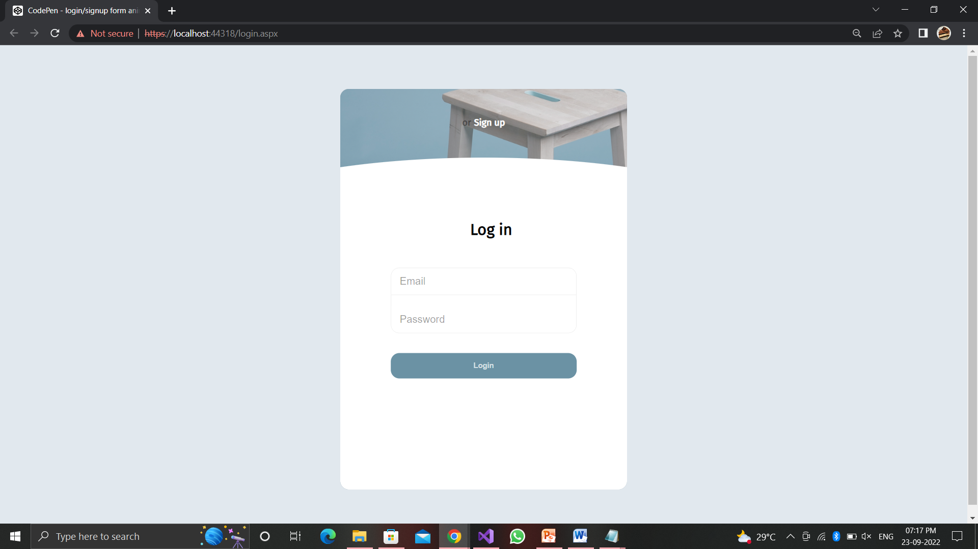

**• Admin Home Page**

* Home page is same for both user and admin but if login peocess was done with admin data than admin can different nav-bar

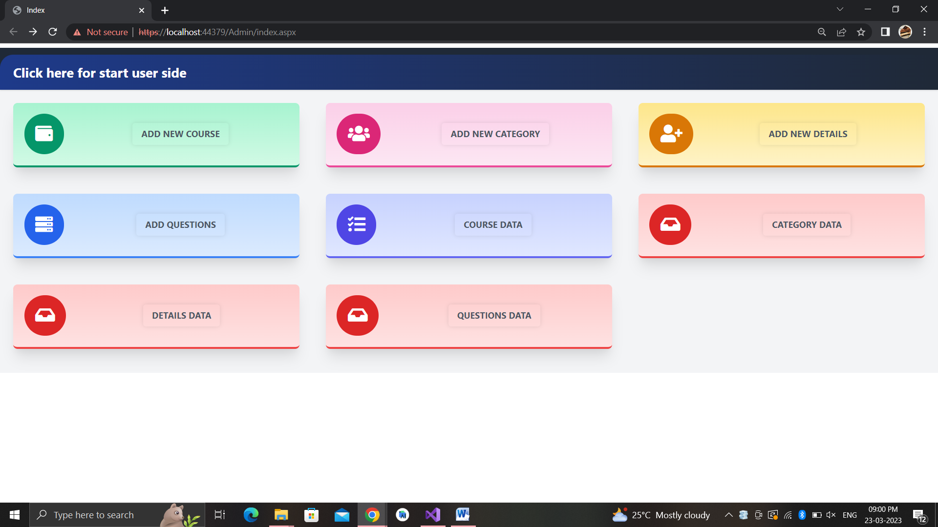

**• Add Courses**

* Admin can add new course with this page.

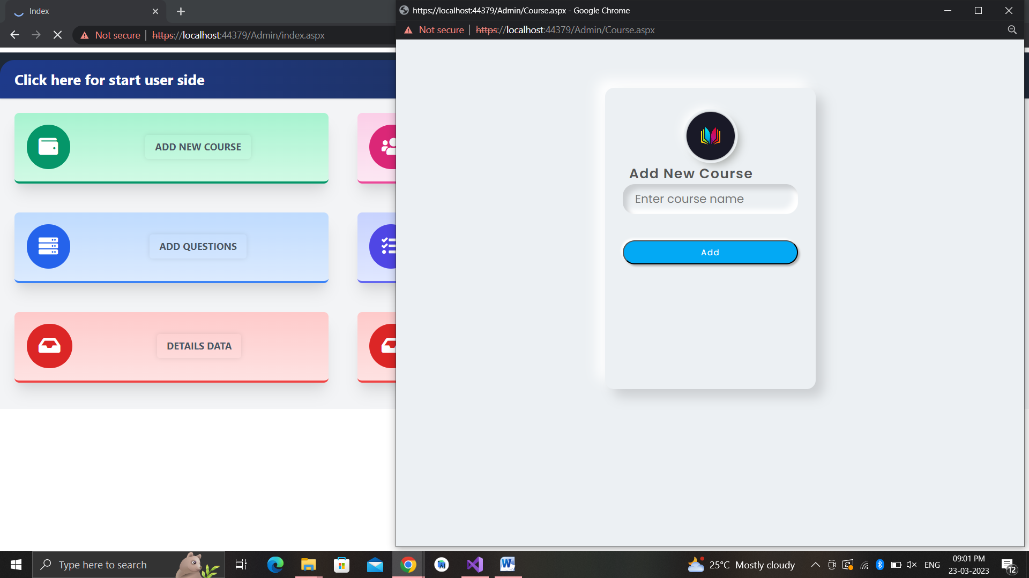

**• Add Category**

* Admin can add new category for different course.

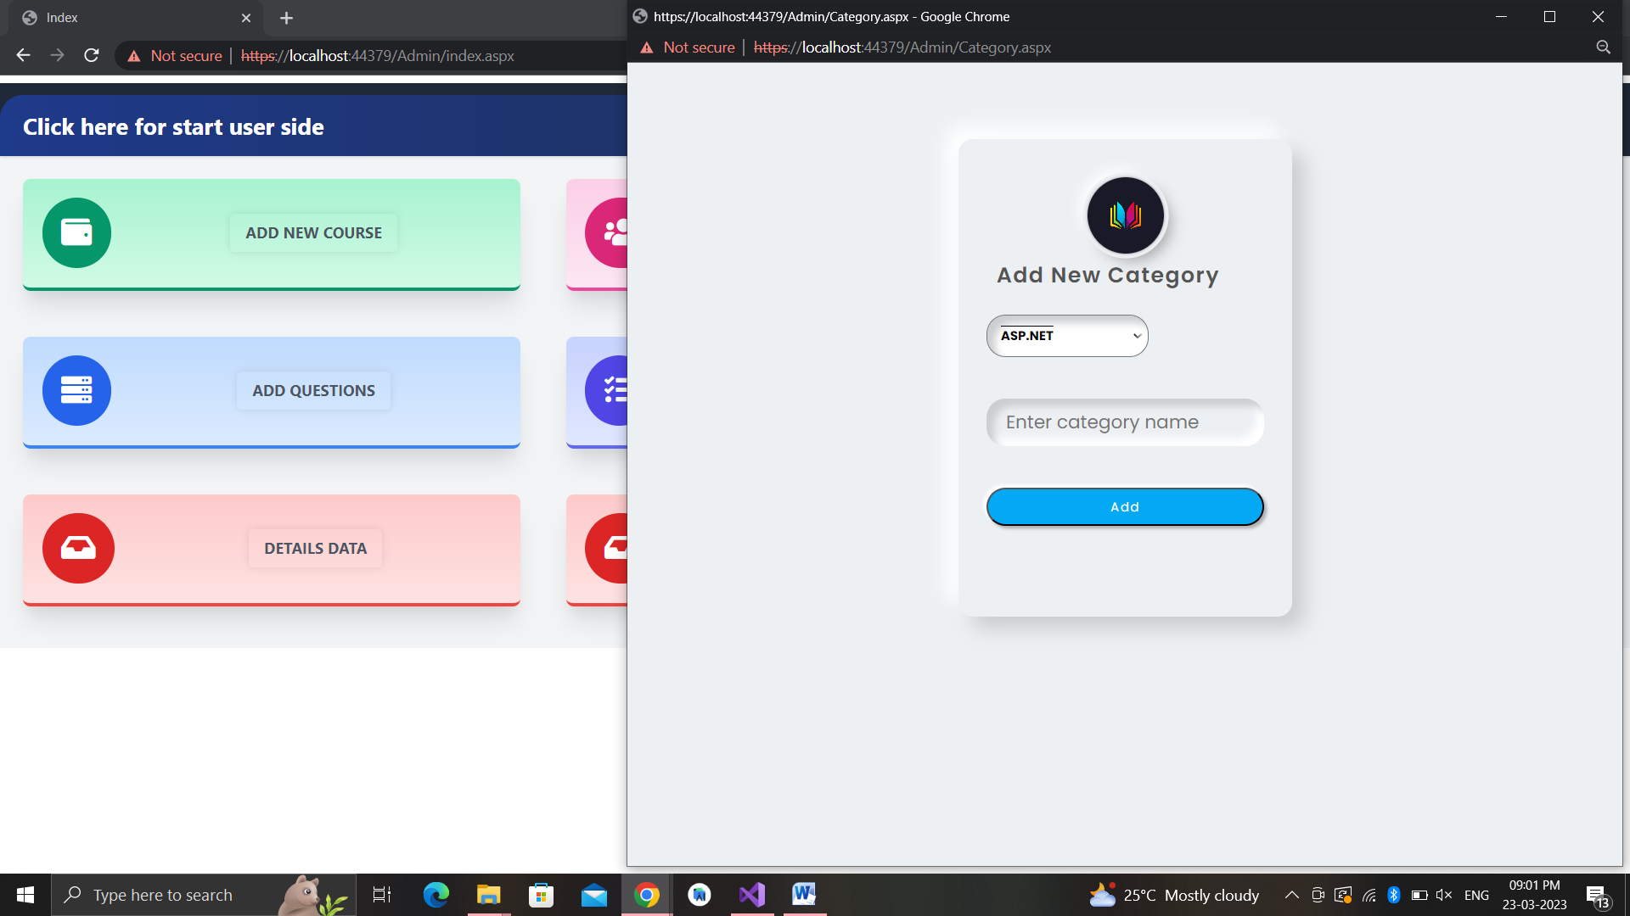

**• Add Details**

Admin can add details with selected course and category.

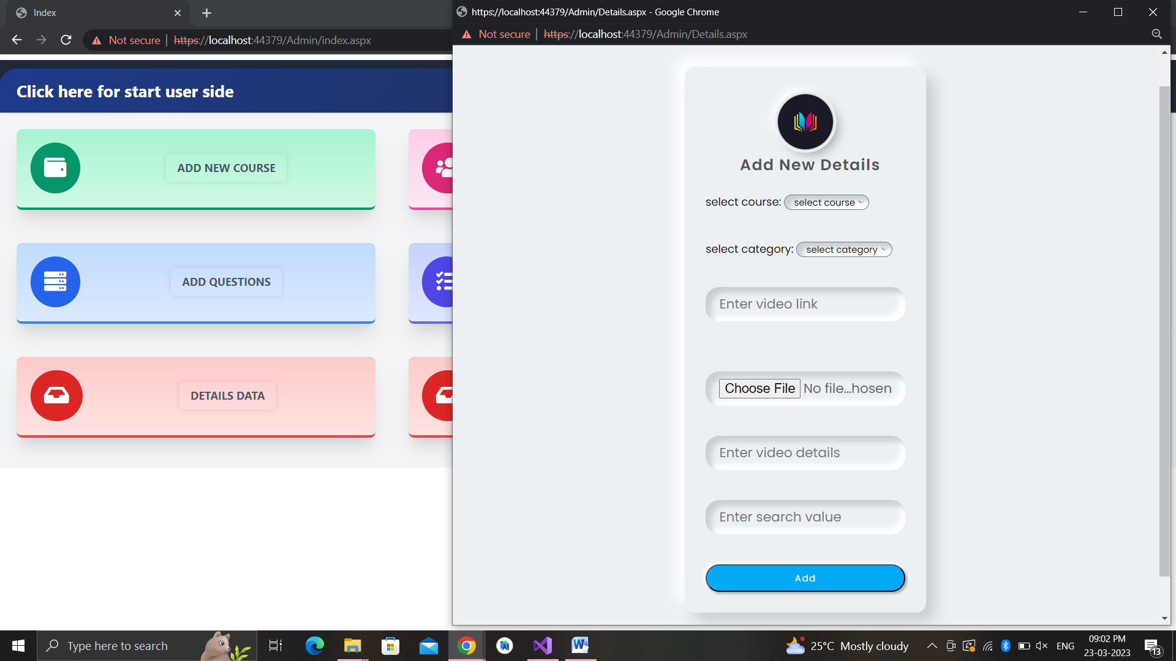

**• Add MCQ Question**

Admin can add MCQ Question with selected course and category.

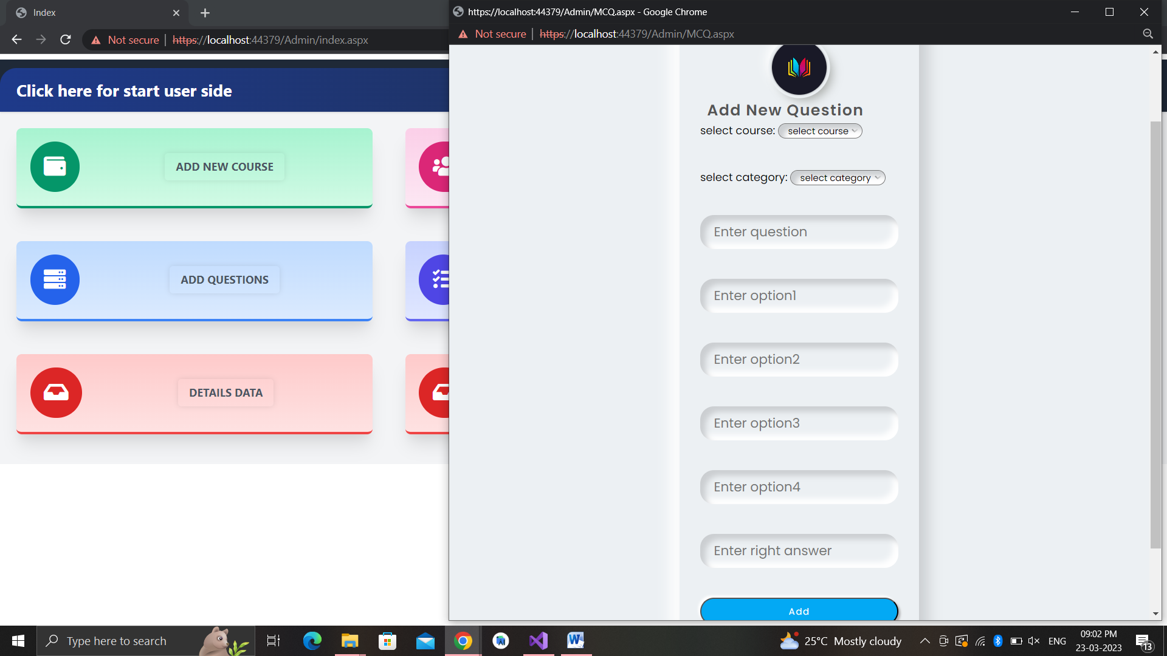

**• Table**

Admin can show the data tables and also update and delete data.

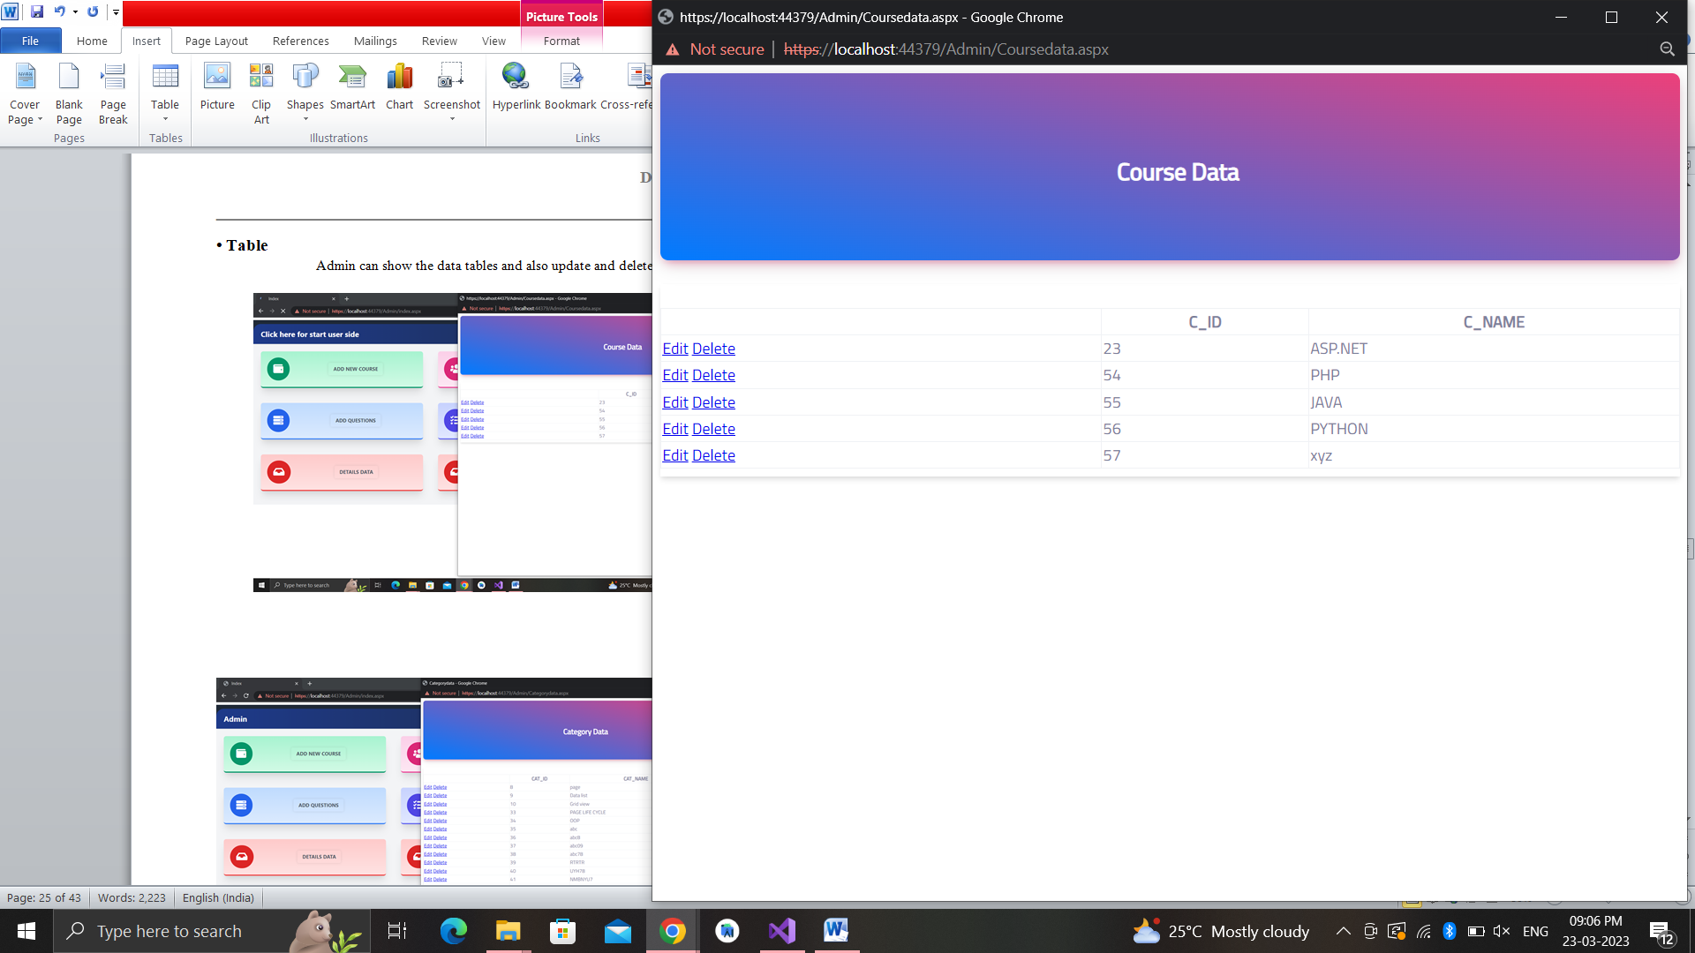

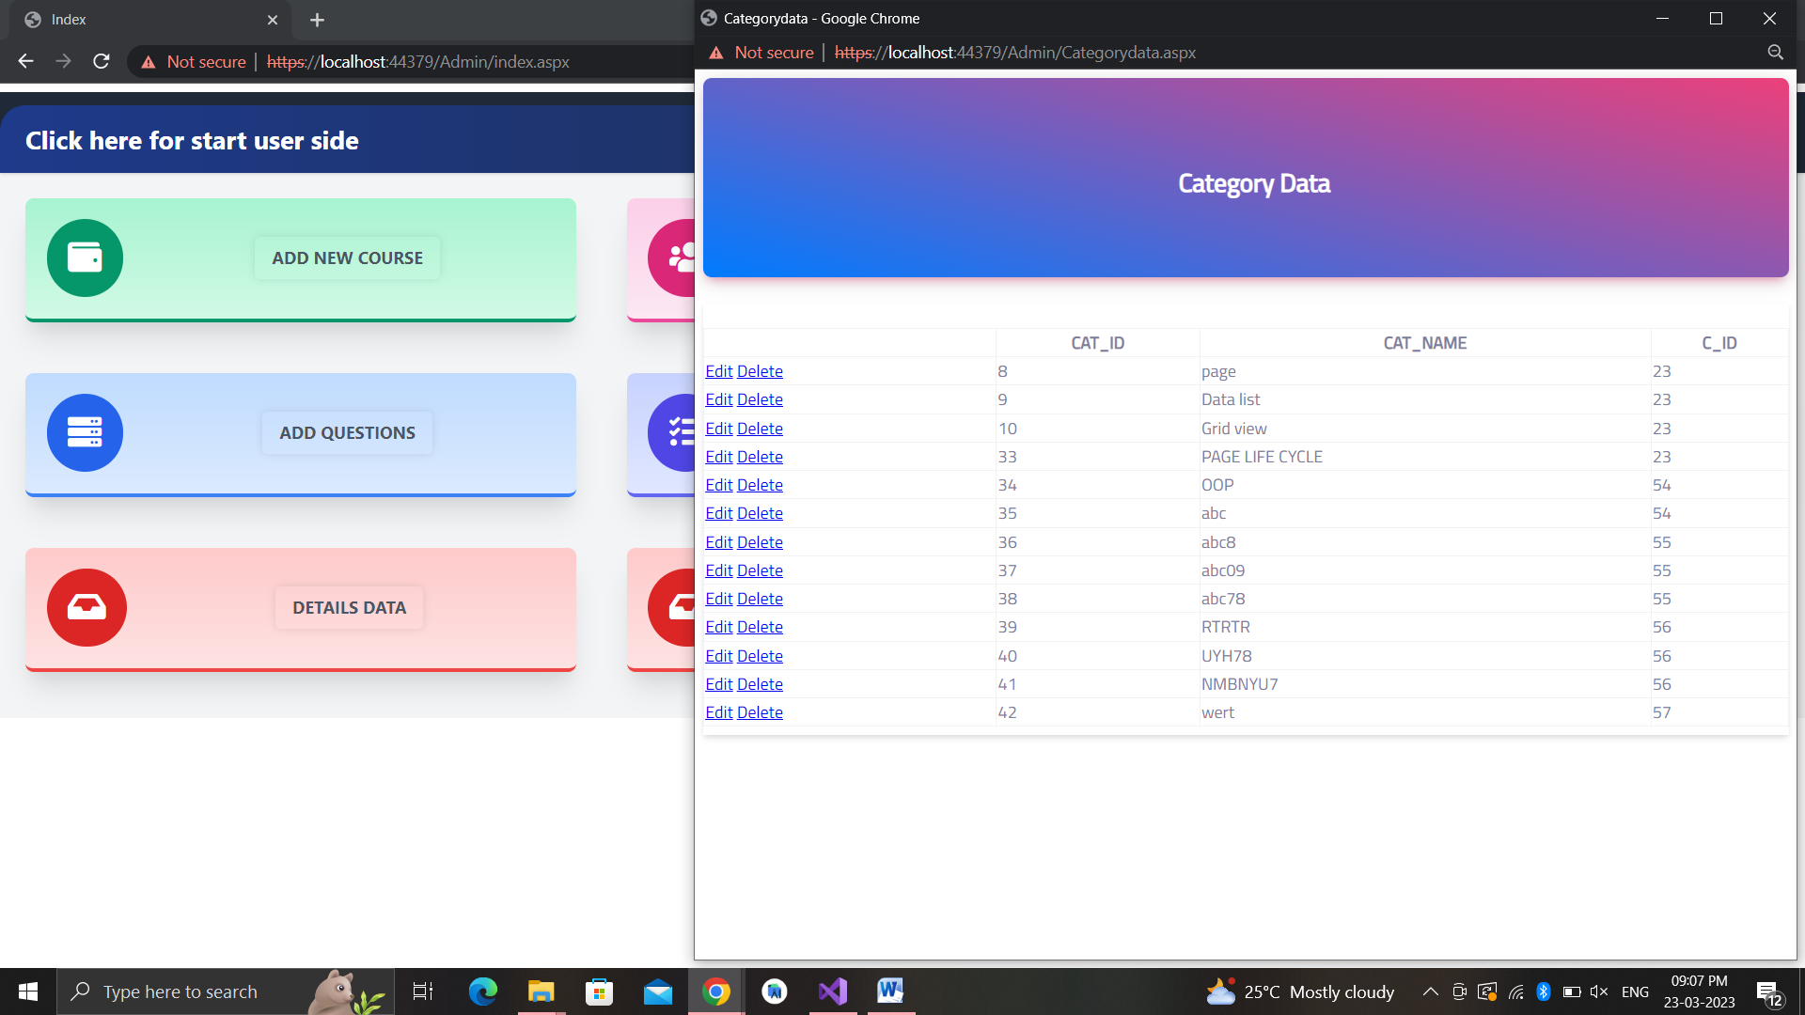

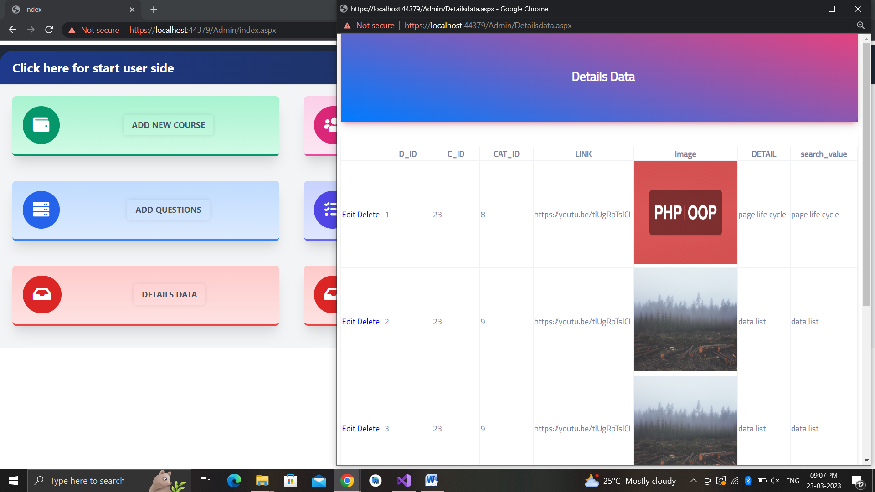

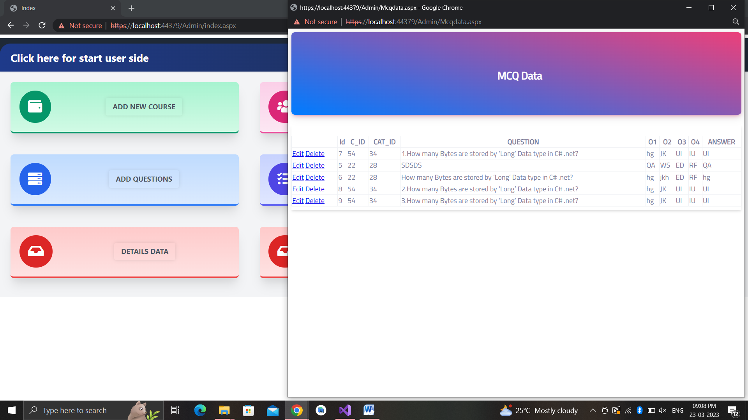

**• Home page of User Without Login**

* Home page of user is looks like given screen shot without login.

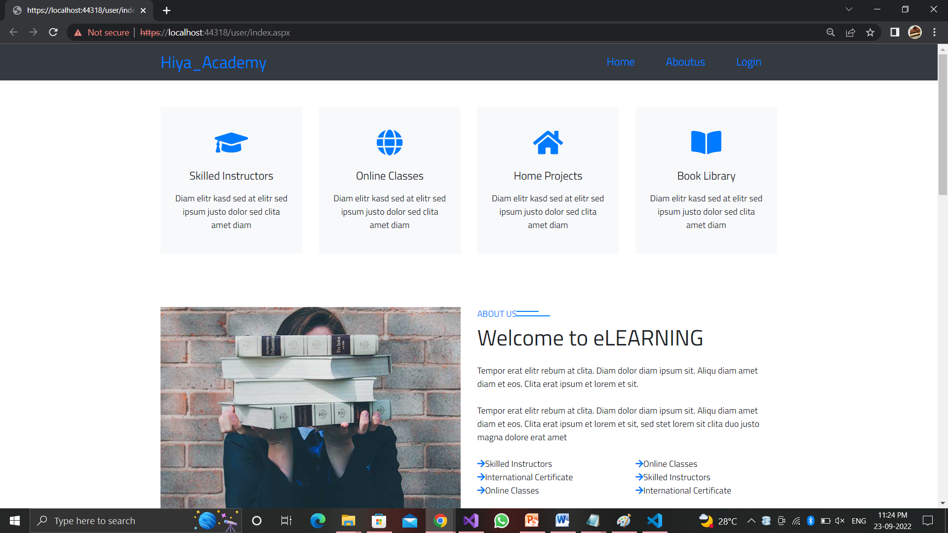

**• Home page of User With Login**

* Home page of user is looks like given screen shot with login.

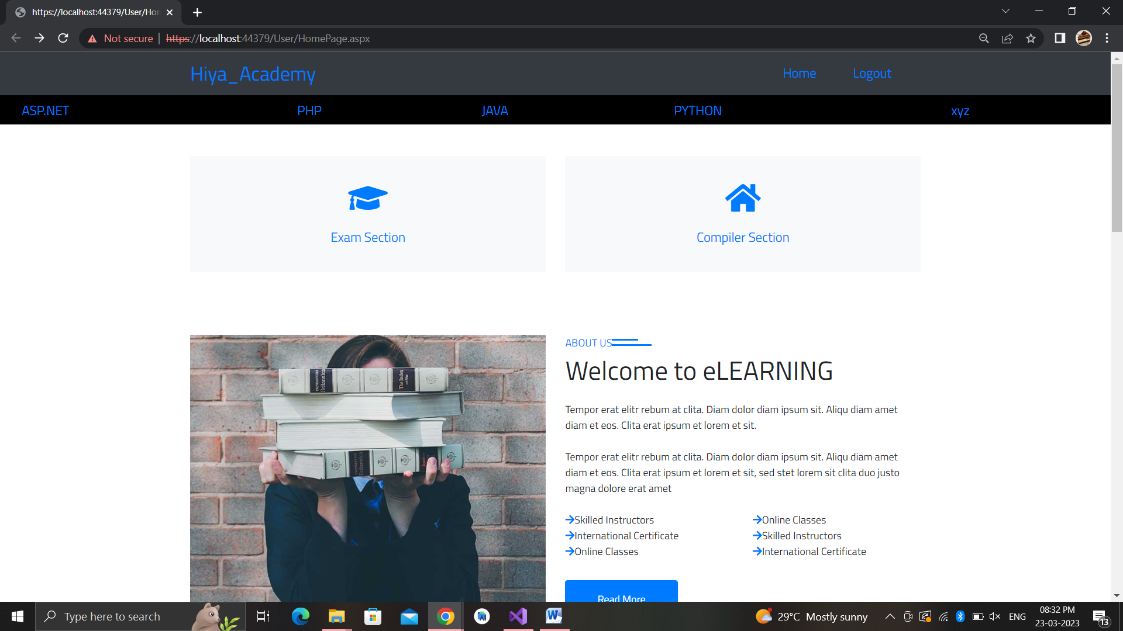

**• Compiler Page**

* User can use code compiler for free.

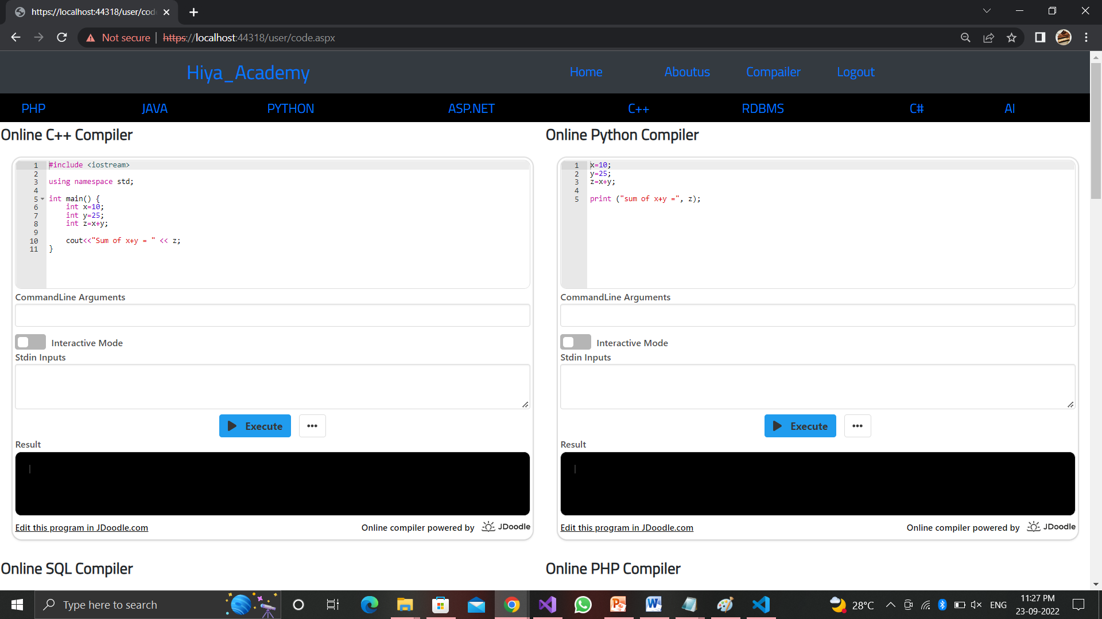

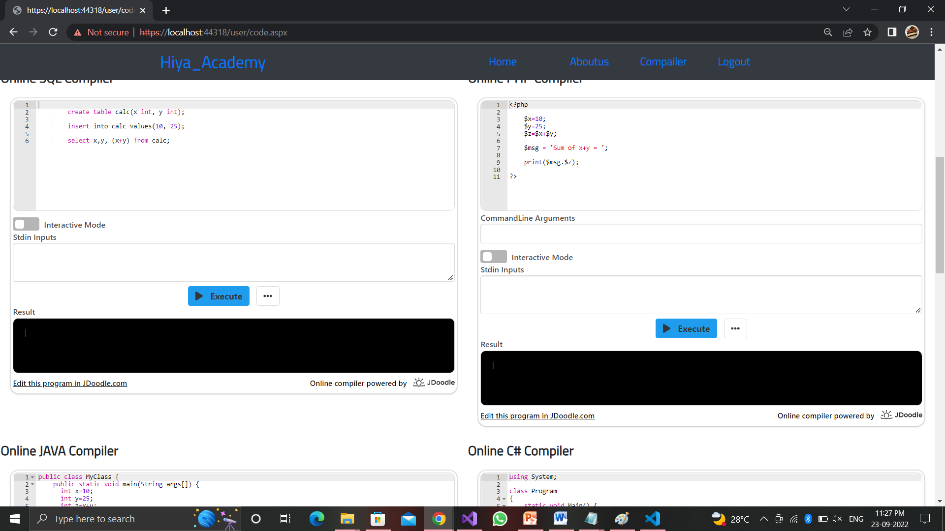

* User can select course which they want
* User can select category which they want

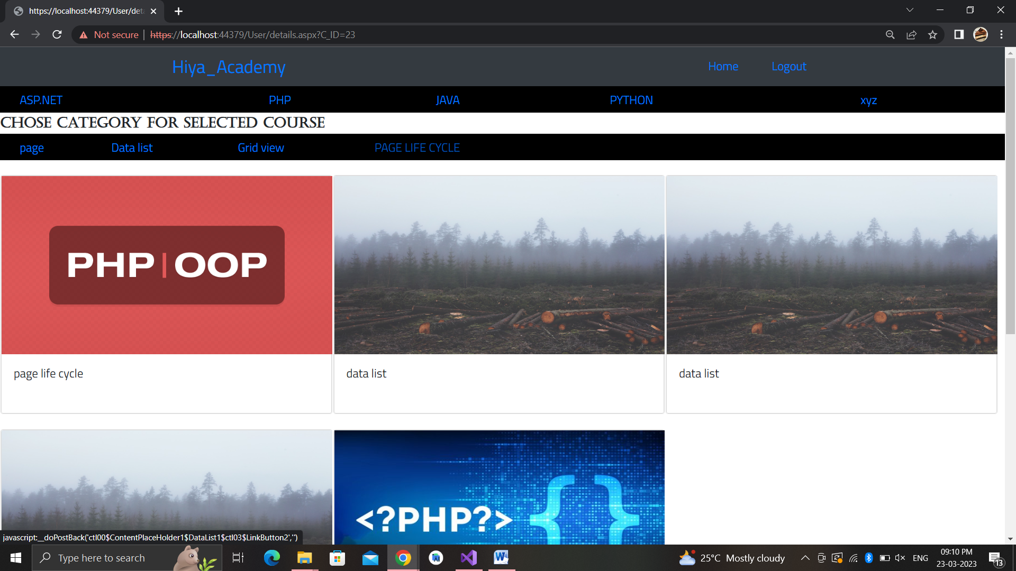

* Watch selected video

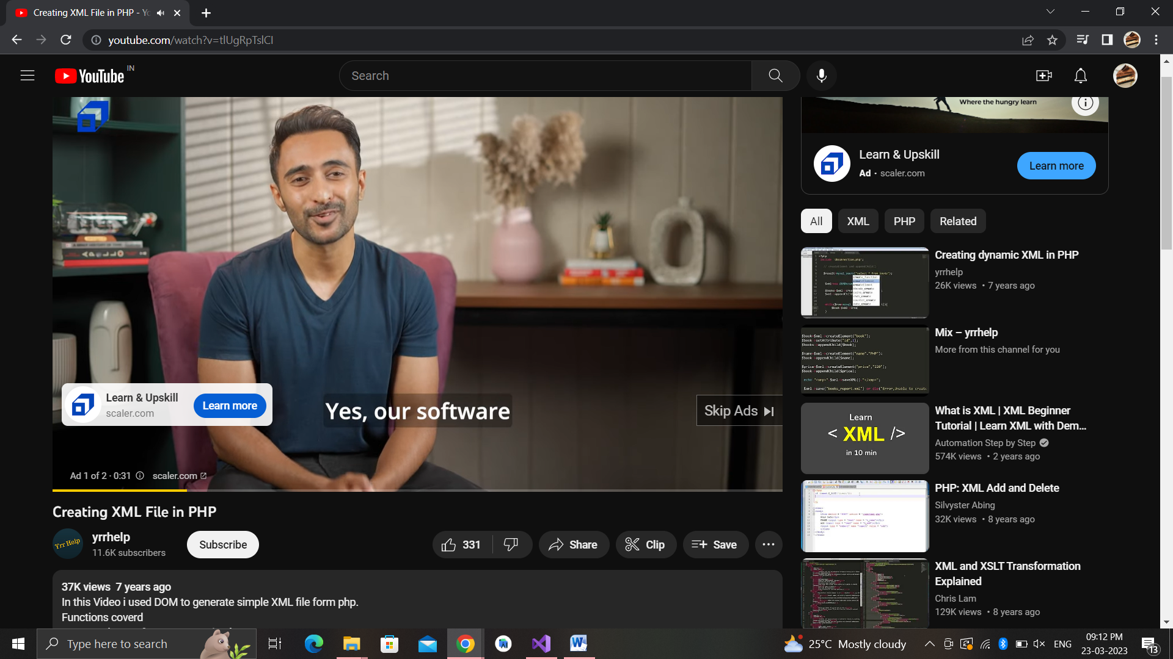

* User can select course for give exam
* User can select category for exam

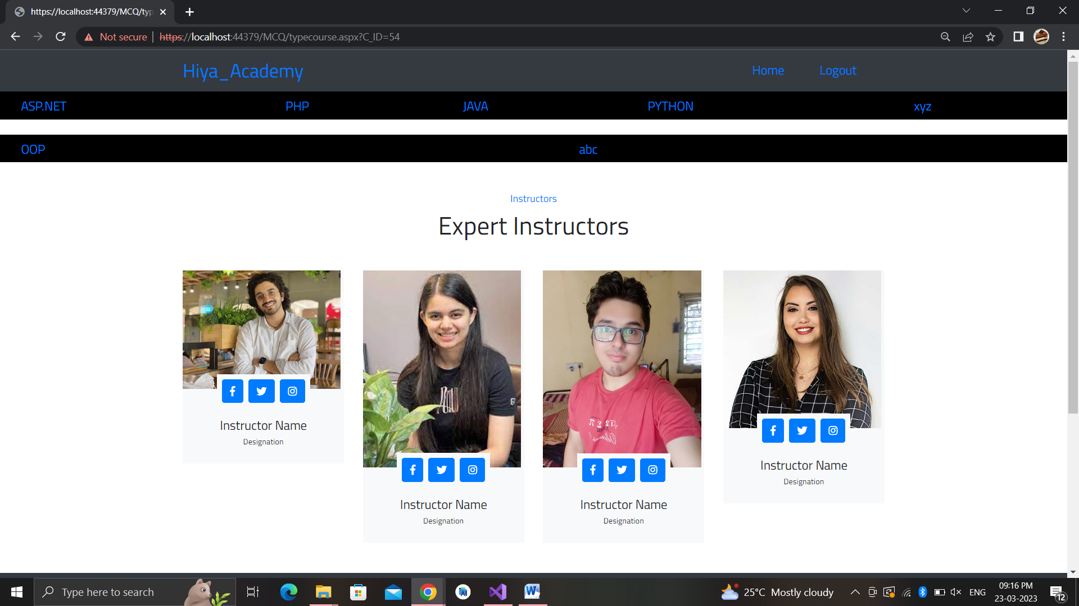

* User can give exam

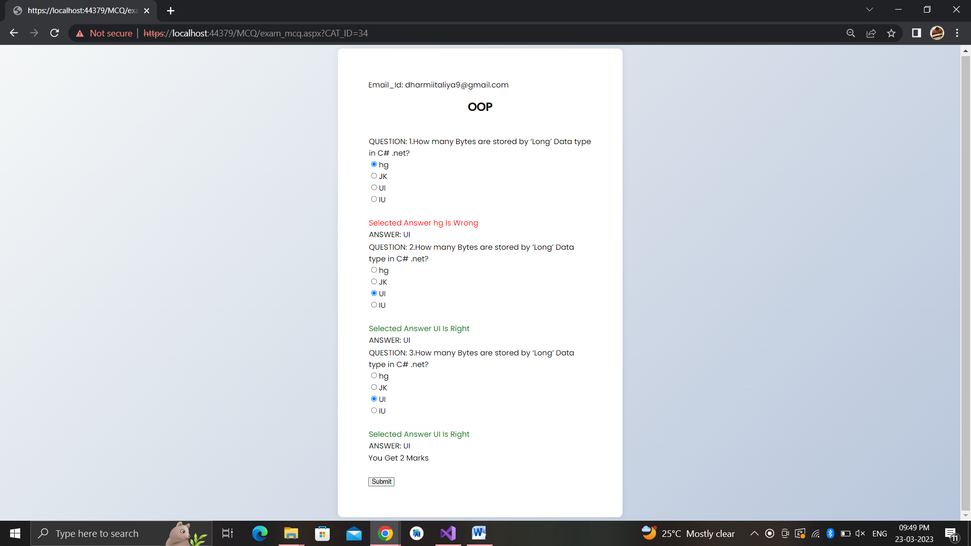

**CODE:**

**• Login**

protected void login12_Click(object sender, EventArgs e)

{

string constr = ConfigurationManager.ConnectionStrings["ConnectionString"].ConnectionString;

SqlConnection con = new SqlConnection(constr);

con.Open();

SqlCommand cmd5 = new SqlCommand("select count(*) from User_login where login_id='" + user1.Text + "' and password='" + password.Text + "' ", con);

SqlCommand cmd = new SqlCommand("select count(*) from Admin_login where Email_id='" + user1.Text + "' and Password='" + password.Text + "' ", con);

int i = Convert.ToInt16(cmd5.ExecuteScalar());

int j = Convert.ToInt16(cmd.ExecuteScalar());

if (i == 1)

{

Session["role"] = "user";

Response.Redirect("user/homepage.aspx?login_id=" + user1.Text);

}

else if (j == 1)

{

Session["role"] = "admin";

Response.Redirect("admin/adcourse.aspx?Email_id=" + user1.Text);

}

else if(i==0 && j==0)

{

string message = "Please Enter Valid Value";

string script = "window.onload = function(){ alert('";

script += message;

script += "')};";

ClientScript.RegisterStartupScript(this.GetType(), "SuccessMessage", script, true);

}

else

{

Session["role"] = "";

}

con.Close();

}

**• Signup**

protected void signup12_Click(object sender, EventArgs e)

{

string constr = ConfigurationManager.ConnectionStrings["ConnectionString"].ConnectionString;

SqlConnection con = new SqlConnection(constr);

SqlCommand cmd = new SqlCommand("insert into User_login (login_id,password) values('" + user.Text + "','" + pass1.Text + "')", con);

con.Open();

cmd.ExecuteNonQuery();

Response.Redirect("user/homepage.aspx");

con.Close();

}

**• Check Availability For Email_Id**

protected void check_Click(object sender, EventArgs e)

{

string constr = ConfigurationManager.ConnectionStrings["ConnectionString"].ConnectionString;

SqlConnection con = new SqlConnection(constr);

SqlCommand cmd = new SqlCommand("select count(*) from User_login where login_id='" + user.Text + "'", con);

con.Open();

cmd.ExecuteNonQuery();

int i = Convert.ToInt16(cmd.ExecuteScalar());

if (i == 1)

{

id1.Text = "not available";

}

else

{

id1.Text = "available";

}

con.Close();

}

**• Insert Course**

protected void Button1_Click(object sender, EventArgs e)

{

string constr = ConfigurationManager.ConnectionStrings["ConnectionString"].ConnectionString;

SqlConnection con = new SqlConnection(constr);

SqlCommand cmd = new SqlCommand("insert into COURSE (C_NAME) values('" + c_name.Text + "')", con);

con.Open();

cmd.ExecuteNonQuery();

string message = "Your Record Have Been Saved Successfully.";

string script = "window.onload = function(){ alert('";

script += message;

script += "')};";

ClientScript.RegisterStartupScript(this.GetType(), "SuccessMessage", script, true);

con.Close();

}

**• Insert Category**

protected void Button1_Click(object sender, EventArgs e)

{

string constr = ConfigurationManager.ConnectionStrings["ConnectionString"].ConnectionString;

SqlConnection con = new SqlConnection(constr);

SqlCommand cmd = new SqlCommand("insert into category (CAT_NAME,C_ID) values('" + TextBox1.Text + "','" + cat.SelectedValue + "')", con);

con.Open();

cmd.ExecuteNonQuery();

string message = "Your Record Have Been Saved Successfully.";

string script = "window.onload = function(){ alert('";

script += message;

script += "')};";

ClientScript.RegisterStartupScript(this.GetType(), "SuccessMessage", script, true);

con.Close();

}

**• Insert Details**

protected void Button1_Click(object sender, EventArgs e)

{

string strname1 = @"~\photos\" + Path.GetFileName(photo.FileName);

photo.SaveAs(Server.MapPath(strname1));

SqlConnection con = new SqlConnection(constr);

SqlCommand cmd = new SqlCommand("insert into C_DETAIL(CAT_ID,C_ID,C_LINK,C_PHOTO,COUSE_DETAILS,search_value) values('"+ddl_cat.SelectedValue+ "','" + ddl_course.SelectedValue + "','" + link.Text + "','" + strname1 + "','" + detail.Text + "','"+search.Text+"')", con);

con.Open();

cmd.ExecuteNonQuery();

string message = "Your Record Have Been Saved Successfully.";

string script = "window.onload = function(){ alert('";

script += message;

script += "')};";

ClientScript.RegisterStartupScript(this.GetType(), "SuccessMessage", script, true);

con.Close();

}

* **Insert MCQ Questions**

SqlConnection con = new SqlConnection(constr);

SqlCommand cmd = new SqlCommand("insert into MCQ(C_ID,CAT_ID,QUESTION,O1,O2,O3,O4,ANSWER) values('" + ddl_course.SelectedValue + "','" + ddl_cat.SelectedValue + "','" + question.Text + "','" + o1.Text + "','" + o2.Text + "','" + o3.Text + "','" + o4.Text + "','" + answer.Text + "')", con);

con.Open();

cmd.ExecuteNonQuery();

string message = "Your Record Have Been Saved Successfully.";

string script = "window.onload = function(){ alert('";

script += message;

script += "')};";

ClientScript.RegisterStartupScript(this.GetType(), "SuccessMessage", script, true);

con.Close();

* **Count score of given exam**

protected void Button1_Click1(object sender, EventArgs e)

{

int Correct = 0;

int NotAnser = 0;

foreach (GridViewRow row in GridView1.Rows)

{

Label A1 = row.FindControl("Label3") as Label;

Label ANSWER1 = row.FindControl("ANSWER") as Label;

RadioButton r1 = row.FindControl("RadioButton1") as RadioButton;

ANSWER1.Visible = true;

A1.Visible = true;

if (r1.Checked == true)

{

if (r1.Text.Equals(ANSWER1.Text))

{

Label SA = row.FindControl("Label2") as Label;

SA.Text = "Selected Answer " + r1.Text.ToString() + " Is Right";

Correct += 1;

SA.ForeColor = System.Drawing.Color.Green;

}

else

{

Label wrongans = row.FindControl("Label2") as Label;

wrongans.Text = "Selected Answer " + r1.Text.ToString() + " Is Wrong";

}

}

else

{

NotAnser += 1;

}

}

foreach (GridViewRow row in GridView1.Rows)

{

Label ANSWER1 = row.FindControl("ANSWER") as Label;

RadioButton r2 = row.FindControl("RadioButton2") as RadioButton;

ANSWER1.Visible = true;

if (r2.Checked == true)

{

if (r2.Text.Equals(ANSWER1.Text))

{

Label SA = row.FindControl("Label2") as Label;

SA.Text = "Selected Answer " + r2.Text.ToString() + " Is Right";

Correct += 1;

SA.ForeColor = System.Drawing.Color.Green;

}

else

{

Label wrongans = row.FindControl("Label2") as Label;

wrongans.Text = "Selected Answer " + r2.Text.ToString() + " Is Wrong";

}

}

}

foreach (GridViewRow row in GridView1.Rows)

{

Label ANSWER1 = row.FindControl("ANSWER") as Label;

RadioButton r3 = row.FindControl("RadioButton3") as RadioButton;

ANSWER1.Visible = true;

if (r3.Checked == true)

{

if (r3.Text.Equals(ANSWER1.Text))

{

Label SA = row.FindControl("Label2") as Label;

SA.Text = "Selected Answer " + r3.Text.ToString() + " Is Right";

Correct += 1;

SA.ForeColor = System.Drawing.Color.Green;

}

else

{

Label wrongans = row.FindControl("Label2") as Label;

wrongans.Text = "Selected Answer " + r3.Text.ToString() + " Is Wrong";

}

}

}

foreach ( GridViewRow row in GridView1.Rows)

{

Label ANSWER1 = row.FindControl("ANSWER") as Label;

RadioButton r4 = row.FindControl("RadioButton4") as RadioButton;

ANSWER1.Visible = true;

if (r4.Checked==true)

{

if (r4.Text.Equals(ANSWER1.Text))

{

Label SA = row.FindControl("Label2") as Label;

SA.Text = "Selected Answer " + r4.Text.ToString()+ " Is Right";

Correct += 1;

SA.ForeColor = System.Drawing.Color.Green;

}

else

{

Label wrongans = row.FindControl("Label2") as Label;

wrongans.Text = "Selected Answer " + r4.Text.ToString() + " Is Wrong";

}

}

}

l1.Text = "You Get " + Correct+ " Marks";

}

**• View Course**

protected void cat_ItemCommand(object source, DataListCommandEventArgs e)

{

if (e.CommandName == "video")

{

Response.Redirect("video.aspx?CAT_ID=" + e.CommandArgument.ToString());

}

}

* **Aspx code**

<asp:DataList ID="DataList2" runat="server" DataKeyField="D_ID" DataSourceID="SqlDataSource2" RepeatColumns="3" RepeatDirection="Horizontal">

<ItemTemplate>

<div class="card mb-3">

<div class="row no-gutters">

<div class="col-md-4">

<asp:HyperLink ID="HyperLink1" runat="server" ImageUrl='<%# Eval("C_PHOTO") %>' NavigateUrl='<%# Eval("C_LINK") %>' ImageHeight="200px" ImageWidth="200px">HyperLink</asp:HyperLink>

</div>

<div class="col-md-8">

<div class="card-body">

<br />

<asp:Label ID="Label2" runat="server" Text='<%# Eval("COUSE_DETAILS") %>'></asp:Label>

</div>

</div>

</div>

</div>

</ItemTemplate>

</asp:DataList>

**6. Testing**

**6.1 Testing Data Inputs ( Data Validations)**

**❖ Login Page:**

|  |  |  |  |  |
| --- | --- | --- | --- | --- |
| NO. | Input | Expected Output | Actual Output | Result |
| 1 | Empty  Email_id | Error | Error | Login Fail |
| 2 | Empty /Wrong password | Error | Error | Login Fail |

**❖ Add Course:**

|  |  |  |  |  |
| --- | --- | --- | --- | --- |
| NO. | Input | Expected Output | Actual Output | Result |
| 1 | Empty  Course | Error | Error | Added Fail |

**❖ Add Category:**

|  |  |  |  |  |
| --- | --- | --- | --- | --- |
| NO. | Input | Expected Output | Actual Output | Result |
| 1 | Empty  Course | Error | Error | Added Fail |
| 2 | Empty  Category | Error | Error | Added Fail |

**❖ Add Details:**

|  |  |  |  |  |
| --- | --- | --- | --- | --- |
| NO. | Input | Expected Output | Actual Output | Result |
| **1** | Empty  Course | Error | Error | Added Fail |
| **2** | Empty  Category | Error | Error | Added Fail |
| **3** | Empty  Link | Error | Error | Added Fail |
| **4** | Empty  Photo | Error | Error | Added Fail |
| **5** | Empty  Course  Details | Error | Error | Added Fail |

* **Add MCQ Questions**

|  |  |  |  |  |
| --- | --- | --- | --- | --- |
| NO. | Input | Expected Output | Actual Output | Result |
| **1** | Empty  Course | Error | Error | Added Fail |
| **2** | Empty  Category | Error | Error | Added Fail |
| **3** | Empty  Question | Error | Error | Added Fail |
| **4** | Empty  Option1 | Error | Error | Added Fail |
| **5** | Empty  Option2 | Error | Error | Added Fail |
| **6** | Empty  Option3 | Error | Error | Added Fail |
| **7** | Empty  Option4 | Error | Error | Added Fail |
| **8** | Empty  Answer | Error | Error | Added Fail |

**6.2 Testing Operations (Actions on each screen)**

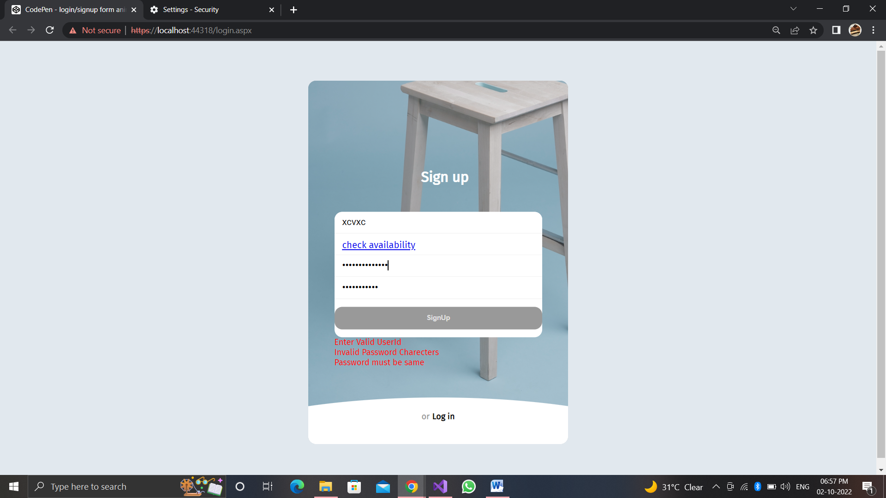

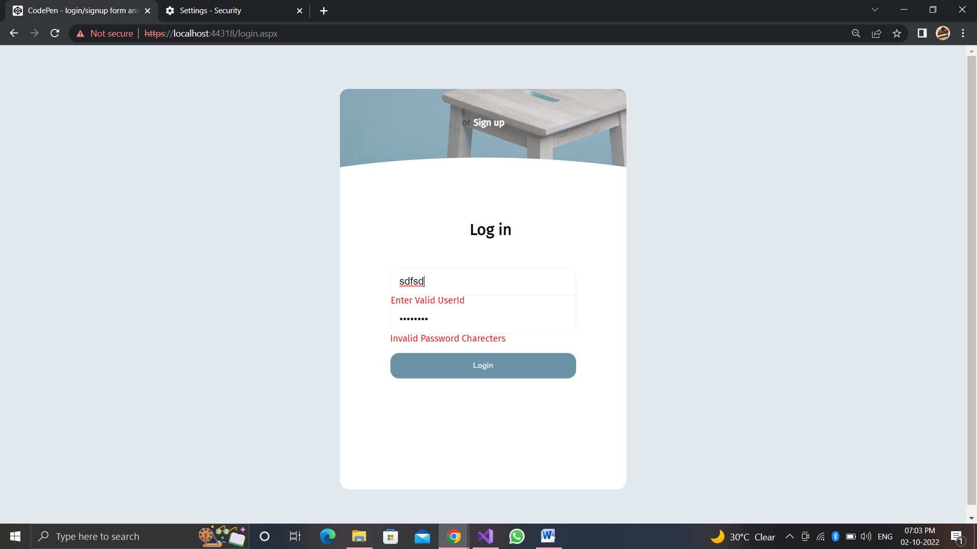

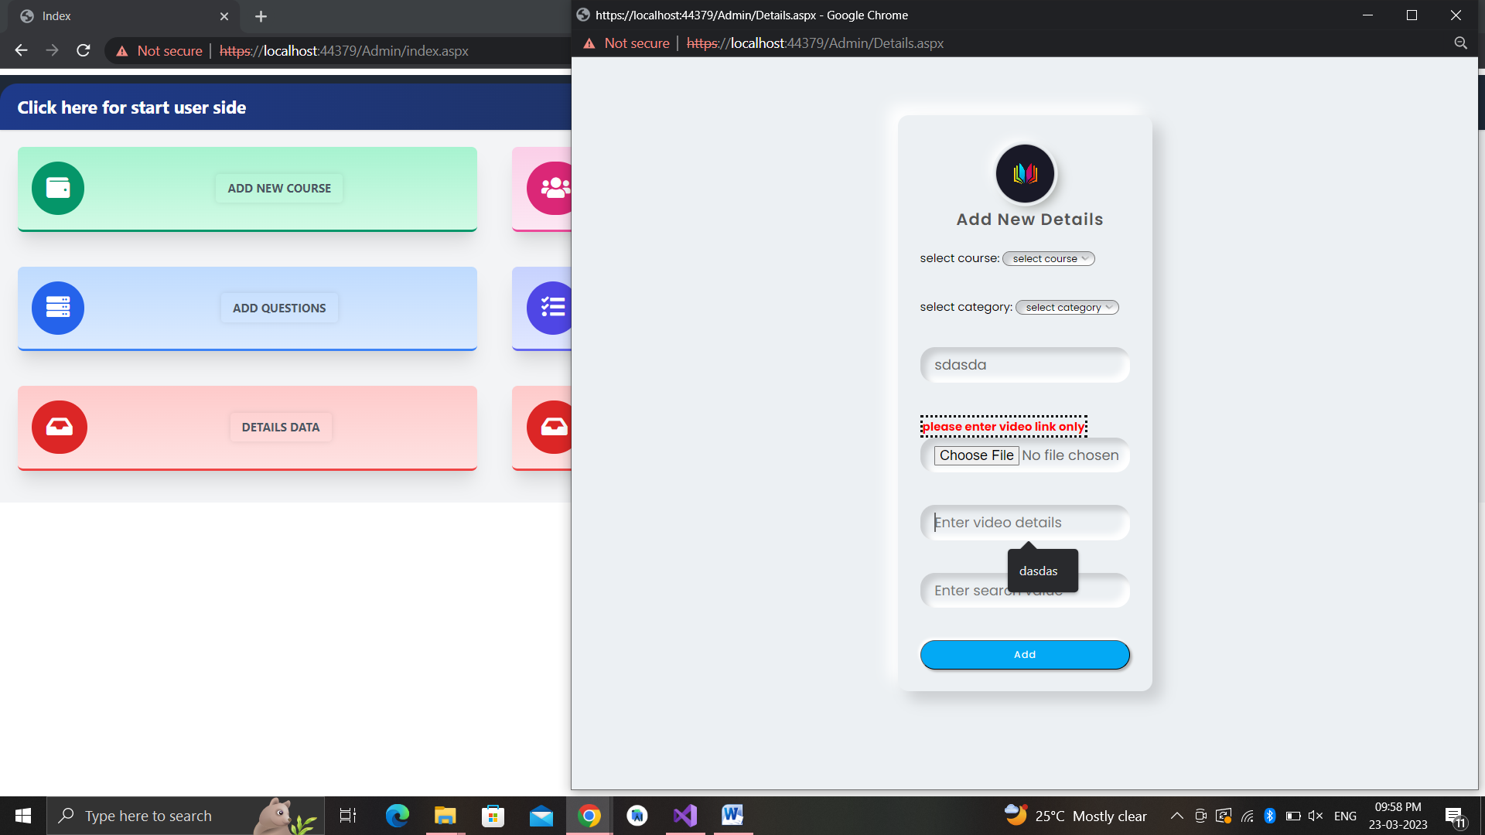

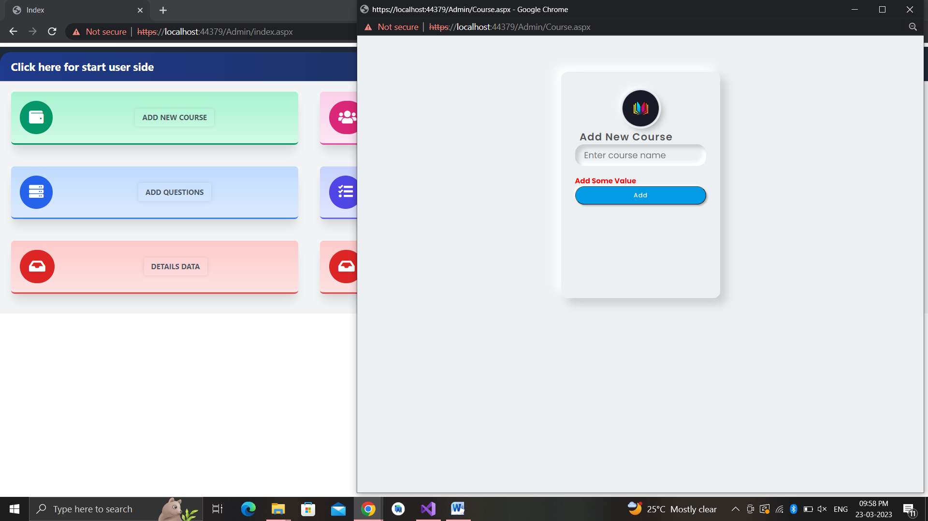

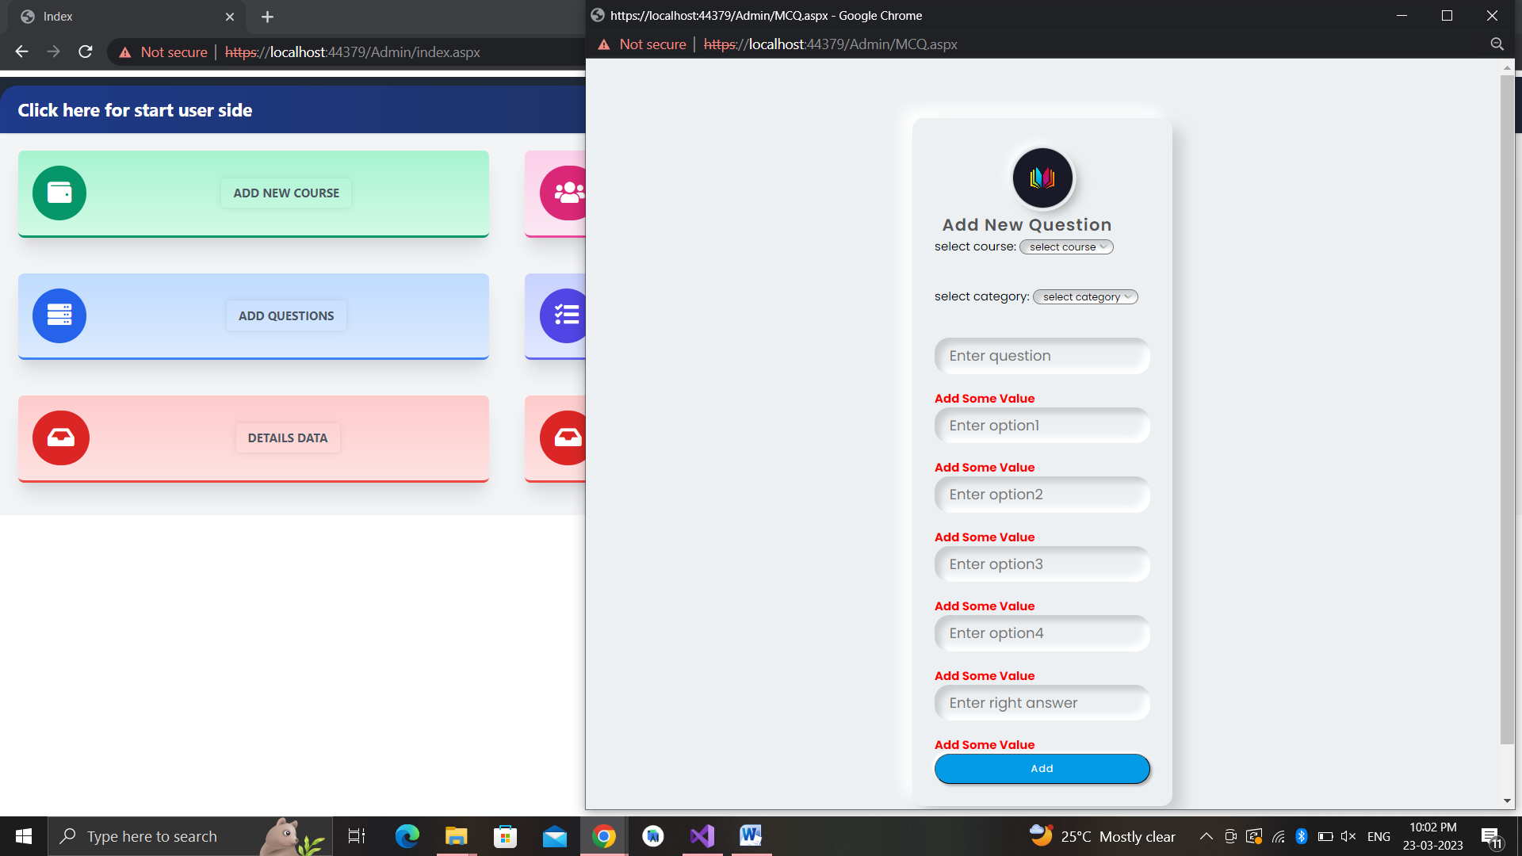**7 .New Tools/ Technologies learned/used**

* Visual Studio 2019:- It is the main development environment in which we will Code.
* Some CSS for page design
* Template field for passing value
* Microsoft Access 2019: It integrates with Visual Studio 2019.
* .NET Framework 4.8 :-It has two phases for compile process.

FCL: Frame work Class Library

CLR: Common Language Runtime

**8.System Limitations**

* Link will be uploaded when you are connected with internet.
* User only able to see their own Resources they do not able to see other user data.
* admin add by only developer of website .

**9.Bibliography & References**

**Website**

* + [www.stackoverflow.com](http://www.stackoverflow.com)
  + [www.aspsnippets.com](http://www.aspsnippets.com)
  + [**www.codeproject.com**](http://www.codeproject.com)
  + **www.geeksforgeeks.org**